Case Study Title: The Olympic Market- Capitalizing on the Olympic Games

Company Name: **Canalytics**

#### **Mission and Vision:** Canalytic’s data-driven solutions empower the Sports media and Sports betting industry to capitalize on the excitement of the Olympic Games and engage more sports fanatics and casual audiences all around the world. It’s a company that capitalizes on the global buzz that is the Olympic games.

Functional area of interest:

* Canadian Excellence in the Olympics games
* Promoting the Olympic fever
* Monetize through selling analytics to Sports Media and Sport Betting Companies

Dashboard Objective:

To be able to represent the past data of Olympics as Visualization which are understandable and easily graspable by Olympic Fanatics or new enthusiasts all over the world. Monitor the status of the Olympics and share updates through customized dashboard.

Scorecard Objective:

Measure how Canada Performs in different disciplines at Olympics.

Understand the Gender Demographics

Find Insights that help Canada bag more medals in the next Olympics.

Fig. 1: Dashboard 1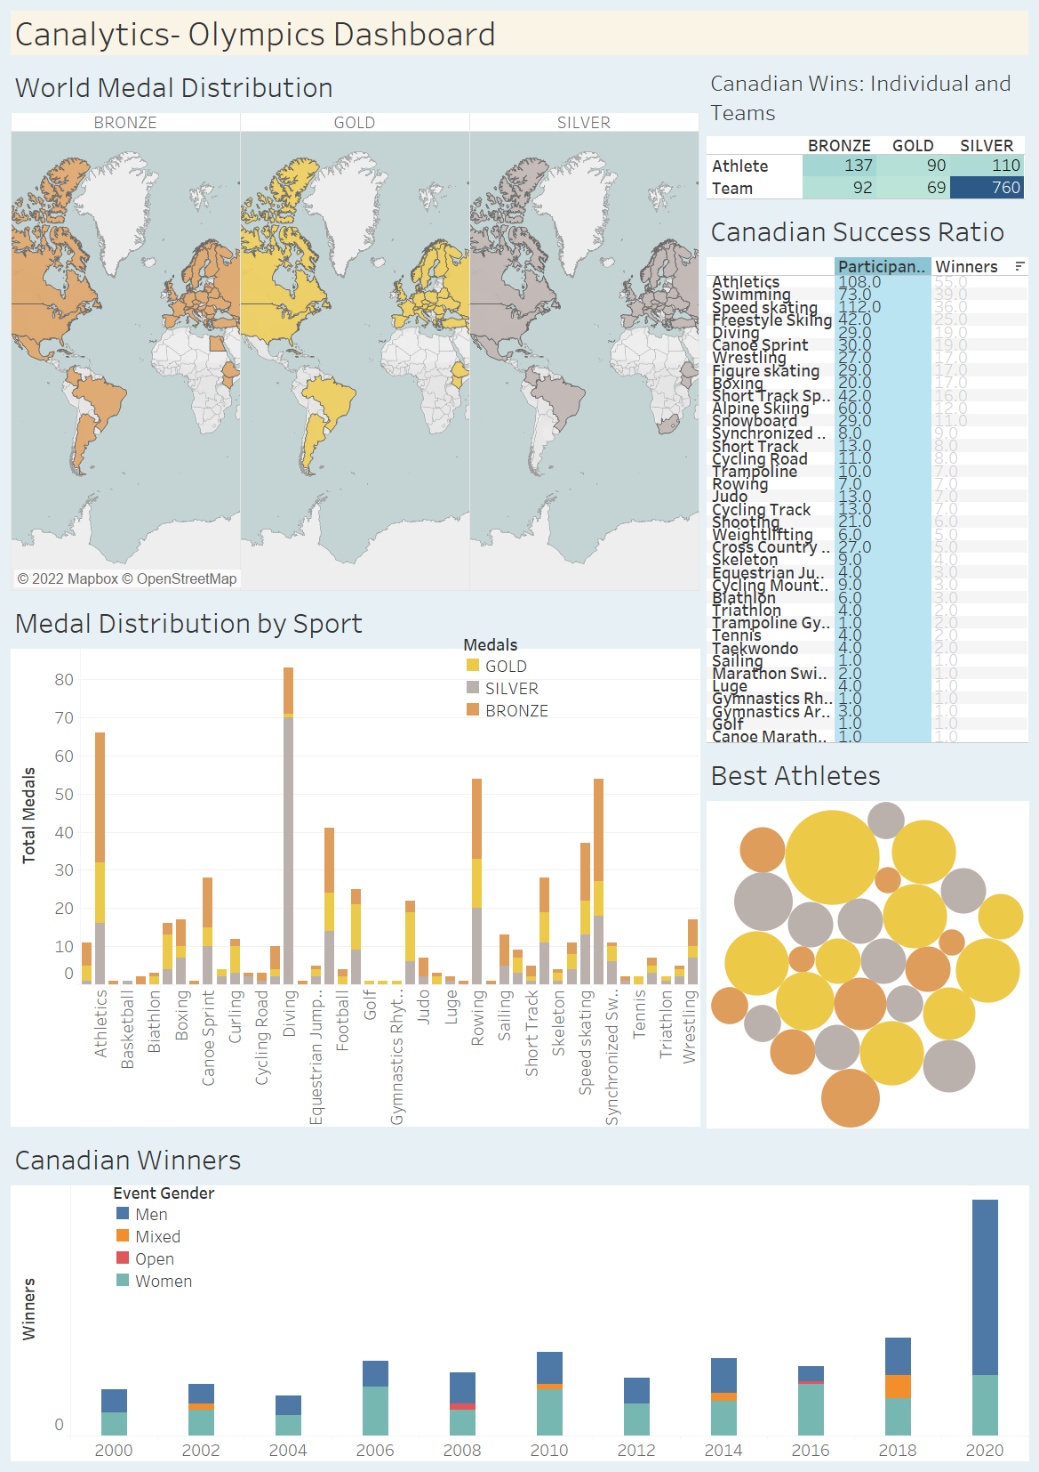

#### DASHBOARD VISUALIZATIONS

World Medal Distribution:

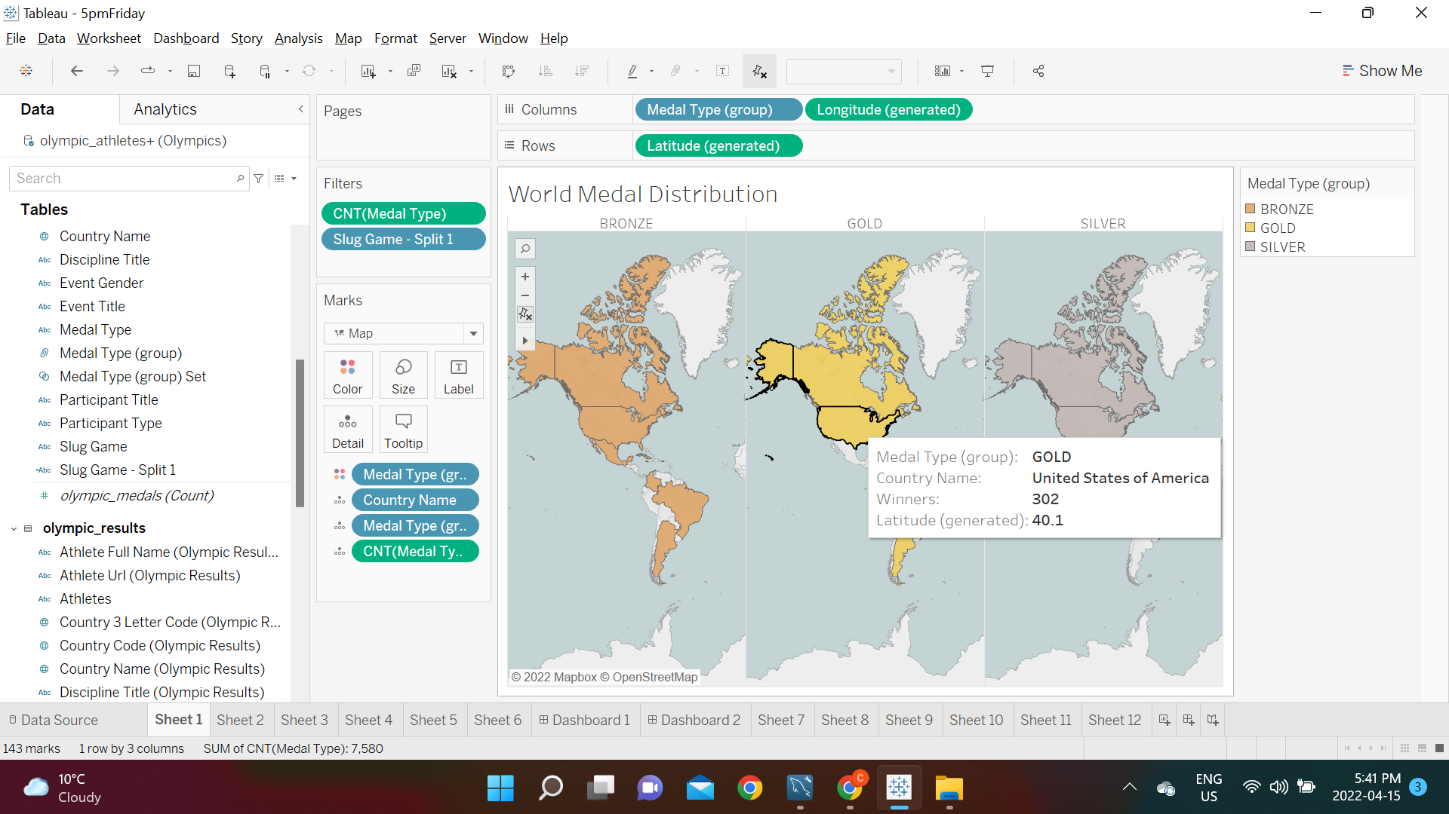

This is an interactive visualization that shows how many gold, silver and bronze medals a country has earned. For Canada this is summarized in a separate visual chart below. Canada has 79 Gold medals, 79 Silver medals, and 99 bronze medals.

Canadian Wins

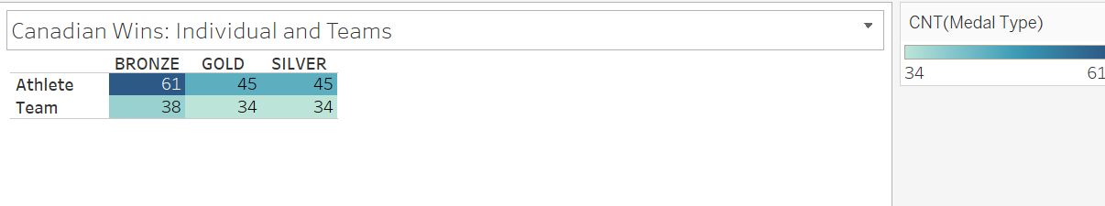

Medal Distribution by Sport

Here we see that over all most of these medals were obtained in Diving, earning the majority as silver medals. Athletics earned a majority of gold medals. 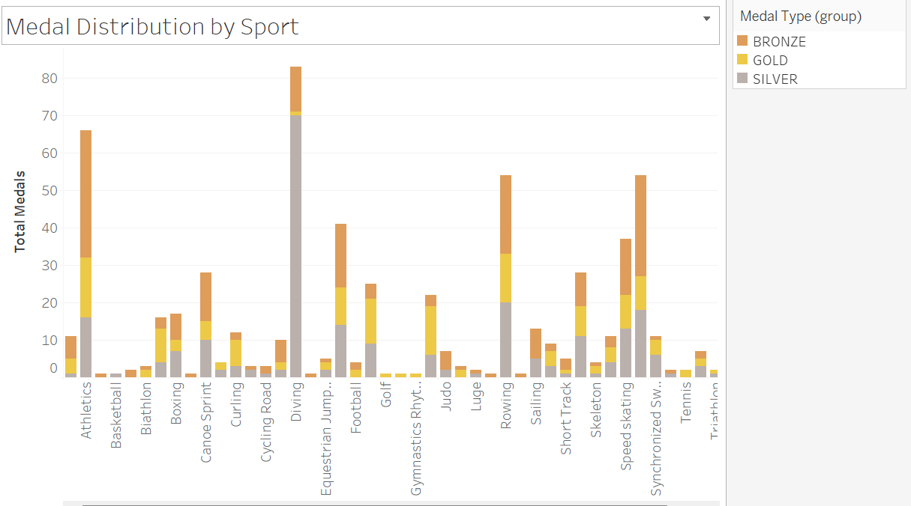

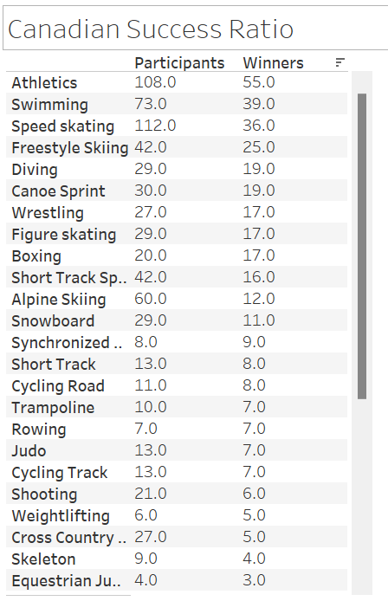

This chart shows the number of participants Canada has sent to the olympics for each sport and how many of those resulted in wins. This is useful because if we only consider the number of wins we are ignoring the fact that an increase in participants increases our chances at getting medals. Seeing the number of participants, we can start to track how much support and how many resources are we allocating to our success in that sport.

Best Athletes

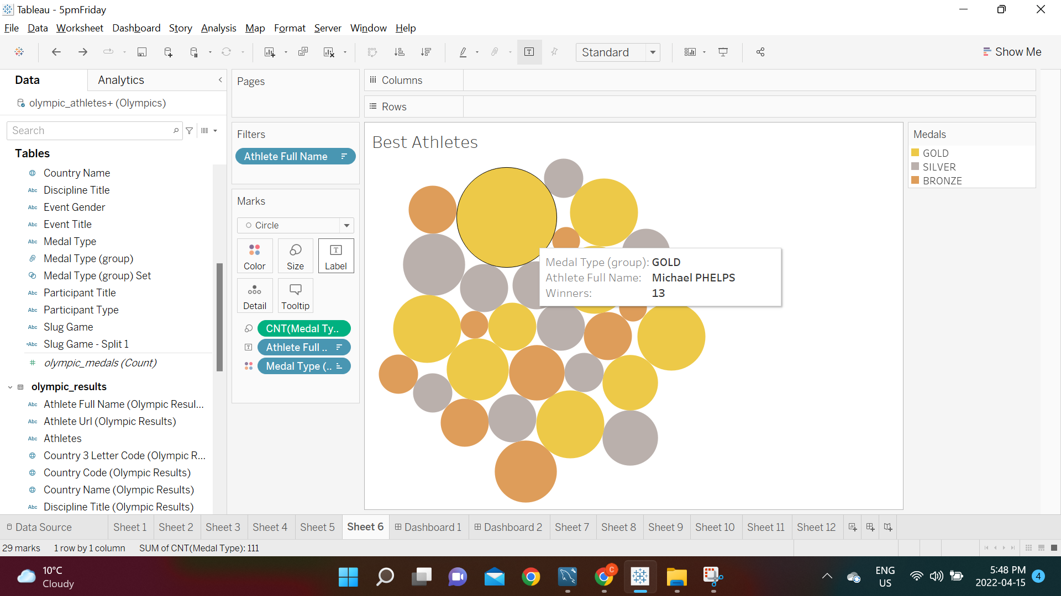

This is another interactive visualization that shows the best athletes as you hover over the circles representing the number of medals by area. The best athlete of all time is Michael Phelps from the United States with 13 medals, but most of the top athletes are from Russia. There are currently no Canadians who broke the top 10.

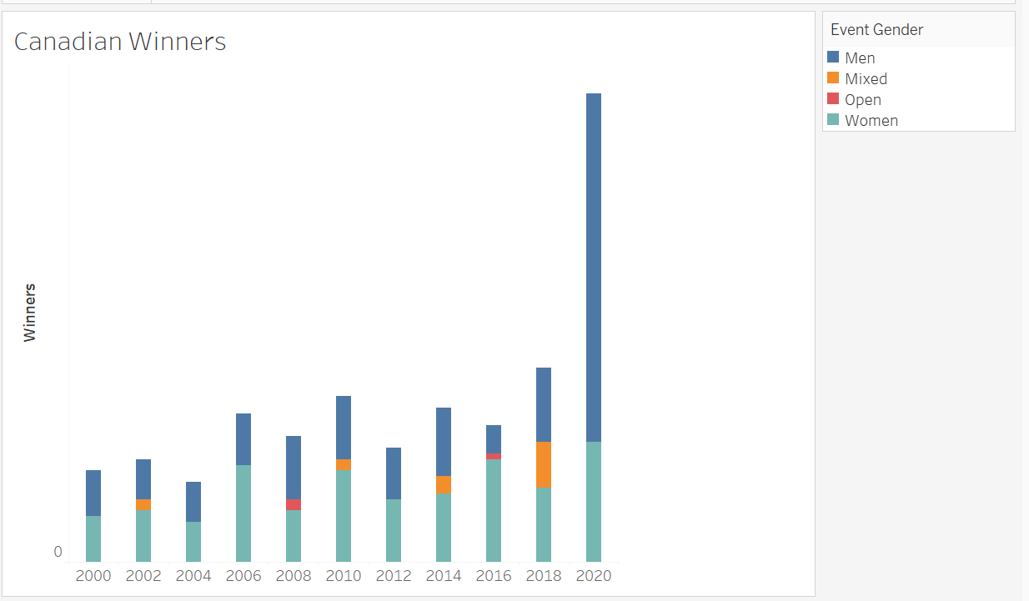

Here we have Canadian winners broken down by Men’s and Women’s sports as well as in Mixed and Open competitions. In the 2020 games, there was a huge increase in Men’s winners while the number of winners in the Women’s category stayed relatively constant in comparison to past years.

#### 

Scorecard Elements

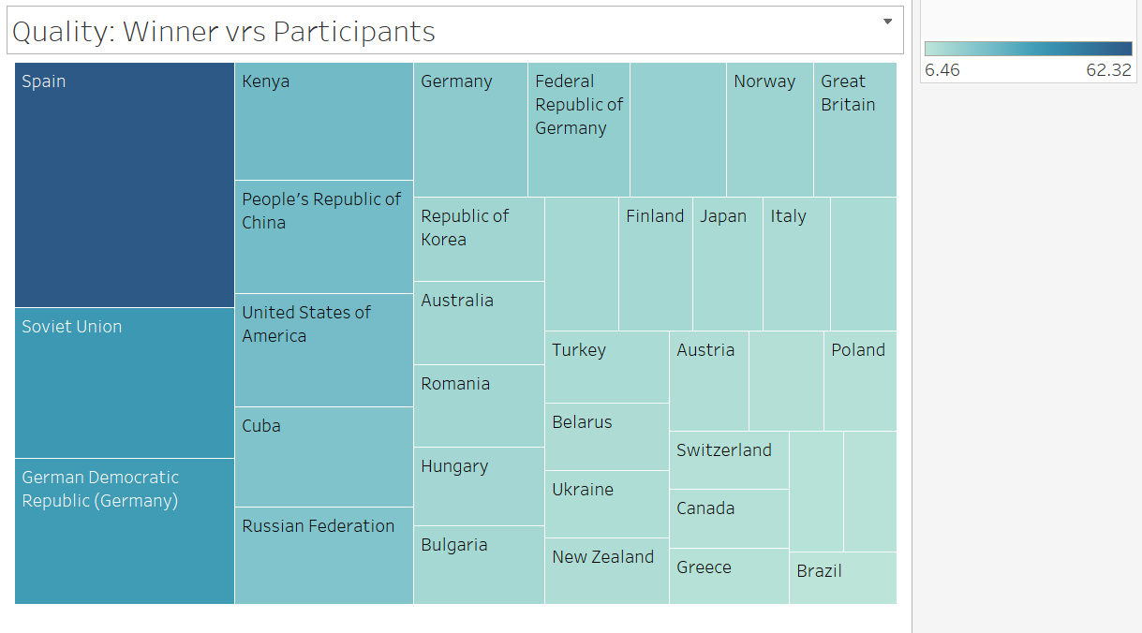

The Scorecard above is a metrics to measure the Quality of Participants. We have calculated this by a calculated field that defines the Winning Percentages out of total Participants.

Canada has a **Success Ratio of 8.4 %.**

**Insight: Spain has a Success Rate of 62 %** i.e. out of every 100 Qualified Participants in the Olympics 62 have won a medal.

This may not mean that Canada is less adept at olympic sports than Spain. This visualization isn’t accounting for how many participants a country is sending. If a country sends fewer athletes than Canada, and Canada wins more having more athletes, the other country may still do better than Canada if enough of their athletes win. In other words, this is a better measurement of how supportive countries are of their lower performing athletes. If Canada wants to be higher by this metric, we could consider only sending athletes we are confident will win a medal.

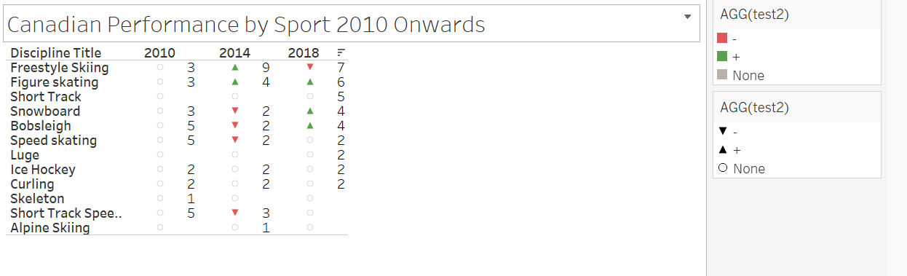

As seen in the above infographic, we discovered that Canada which had won 9 medals in 2014 in Freestyle Skiing has decreased in its performance in the last Olympics 2018. Need to do an in depth research on this sport to figure out the root cause.

**Insight**: Canada Excels in the Winter Olympics because of the Sports type which are more often played in Canada.

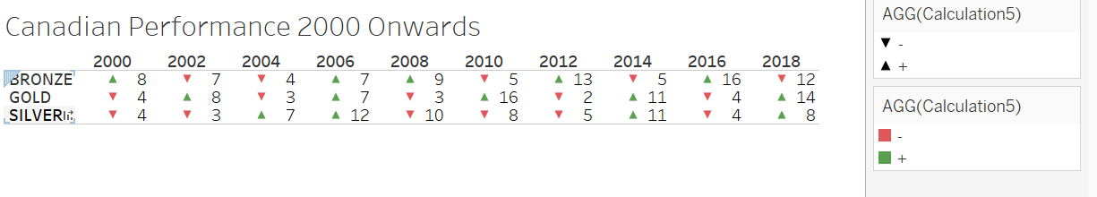

**2018** was a record breaking year for Canada with whooping 34 medals in total. 14 Gold Medals being the second highest Gold Medals that Canada Won. There was a slight decrease in the bronze medal but Canada made it up with the Gold medals.

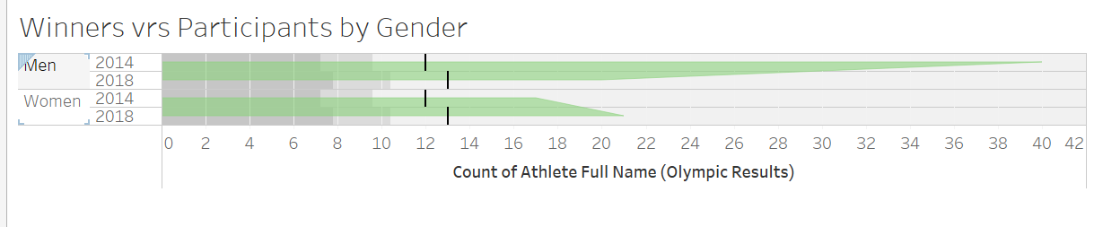

**The** above visualization shows the participants and winners w.r.t gender. The Men’s category has a steeper slope than the Women’s. This could be because in general men are more encouraged to get involved in sports than women. This means that Men are more likely to feel comfortable in taking the risk of failure, whereas women are more likely to only participate in the olympics if they are good enough.

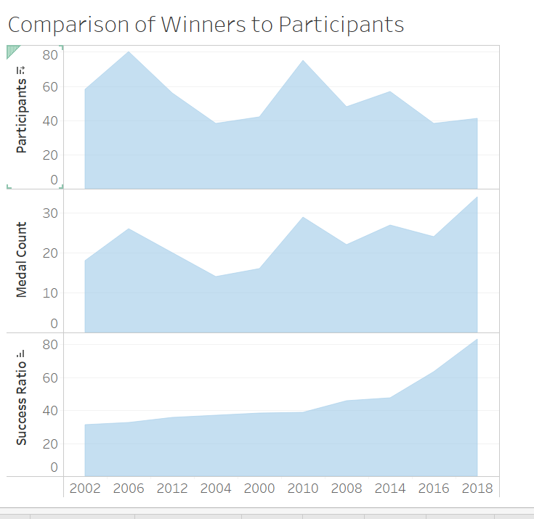

**Some key observations** from our time spent analyzing the data was that despite the Olympics being politically neutral, richer countries did tend fare better getting wins than poorer countries. Spain had the most medals out of all countries. It may not be fair or useful to compare ourselves with countries that don’t have the resources to put their best effort towards the olympics.

We also noticed that there was no Olympics in 1944 because it was canceled due to World War 2.